**Email Admin - Exchange Server Report**

COMP-10017-01 - Email Server Admin

8 April 2024

Chintan Ghori / 000900468

## Table of Contents Page

Introduction 3

Exchange Server 2019 Compatibility Requirements 3

Exchange Server 2019 Installation Prerequisite 4

Active Directory Preparation for Exchange Server 2019 5

Prerequisites for Mailbox Server Role 7

Exchange 2019 Post-Installation Task 8

Lesson Learned 10

# **Introduction**

# The aim of this document was to outline the effective setup and customization of three virtual machines, allowing them to assume various roles and communicate with each other. Additionally, these machines were configured to send and receive both encrypted and unencrypted emails internally. This task was primarily accomplished using a combination of graphical interface tools and some command-line operations over a period of seven weeks. The completion of the project was facilitated by adhering to provided instructions and leveraging prior experience with Exchange 2019 and Oracle VM.

# Top of Form

# **Exchange Server 2019 Compatibility Requirements**

# During the setup and configuration of Exchange Server 2019, I ensured it was tailored to function as an operational email server for a specific domain. Key requirements included enabling the server to connect to and exchange encrypted emails with other virtual machines within the same domain. This configuration proves beneficial for scenarios where a company's workforce is interconnected via a shared domain within an office setting, allowing for centralized management and monitoring of email traffic. The setup accommodates various email clients such as OWA (Outlook Web Access) and **Thunderbird** and can be expanded to support additional email applications. Moreover, it facilitates the creation of multiple user mailboxes directly within the Exchange Server environment**.**

# **Exchange Server 2019 Installation Prerequisite**

To prepare for the installation of Exchange Server 2019, I undertook the setup and configuration of the domain controller virtual machine. This virtual machine operates on the Windows Server 2019 Standard operating system and was allocated a minimum of 2GB of memory for optimal performance. Within the domain controller, I established forward lookups for IMAP, mail, SMTP, and webmail to guarantee seamless functionality of the Exchange Server and smooth email transmission. These forward lookups are configured to utilize the Exchange Server's fully qualified domain name and IP address to ensure proper operation.

Top of Form

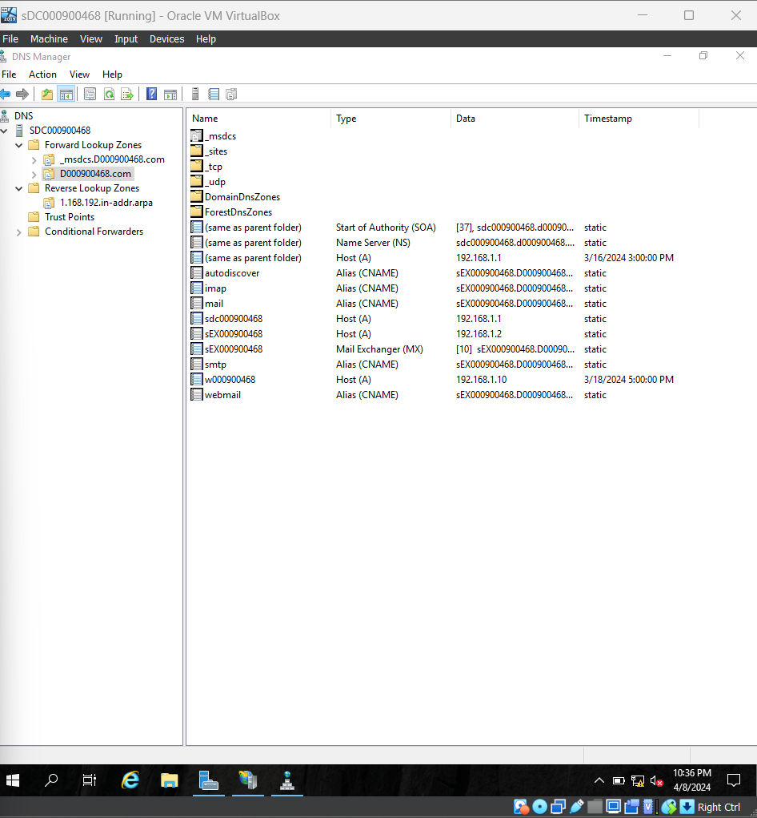

# Active Directory Preparation for Exchange Server 2019

In preparation for configuring the Active Directory for the Exchange Server, I ensured continuous administrative privileges and confirmed my membership in both the schema admin group and the enterprise admin group. This precaution was essential as the Exchange Server VM required privileges from these groups to successfully complete the schema prerequisite analysis/setup. The schema holds all data definitions for Active Directory Domain Services across the entire enterprise, making it crucial to be part of this group to facilitate updates.

Another essential step involved ensuring the Active Directory was poised to accommodate an Exchange organization. Executing a specific command enabled the Exchange Server to generate containers, objects, and other necessary elements within the Active Directory to store organizational information.

Finally, a command was executed to specify the Active Directory domain where Exchange servers would be installed. Following this step, we were poised to initiate the setup command to establish the Exchange Server.

# **Prerequisites for Mailbox Server Role**

Before setting up a standalone Exchange Server, several prerequisite programs must be installed to ensure smooth operation. These include Microsoft Visual C++ 2013, Microsoft Unified Communications Managed API 4.0, and Web Platform Installer 5.1. Once these programs are downloaded and the necessary commands for the prerequisites are executed, the final step involves running the ./setup command. This command initiates the installation process, opening a wizard that guides through the setup to fully establish the Exchange Server and ensure its proper functioning.

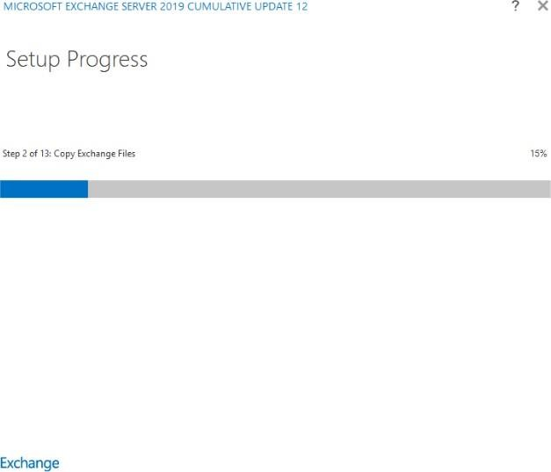

Once this wizard installation is finished, we now have a working exchange server

(almost).

# **Exchange 2019 Post-Installation Task**

There are several post-installation tasks necessary to enable email sending and receiving. Among these tasks is the addition of users and their respective mailboxes. In my Exchange Server setup, I incorporated three users named and alongside the administrator.

Top of Form

Another step is to create a certificate so that we can secure our exchange server, this will also allow users not to get a warning when trying to access our servers

OWA.

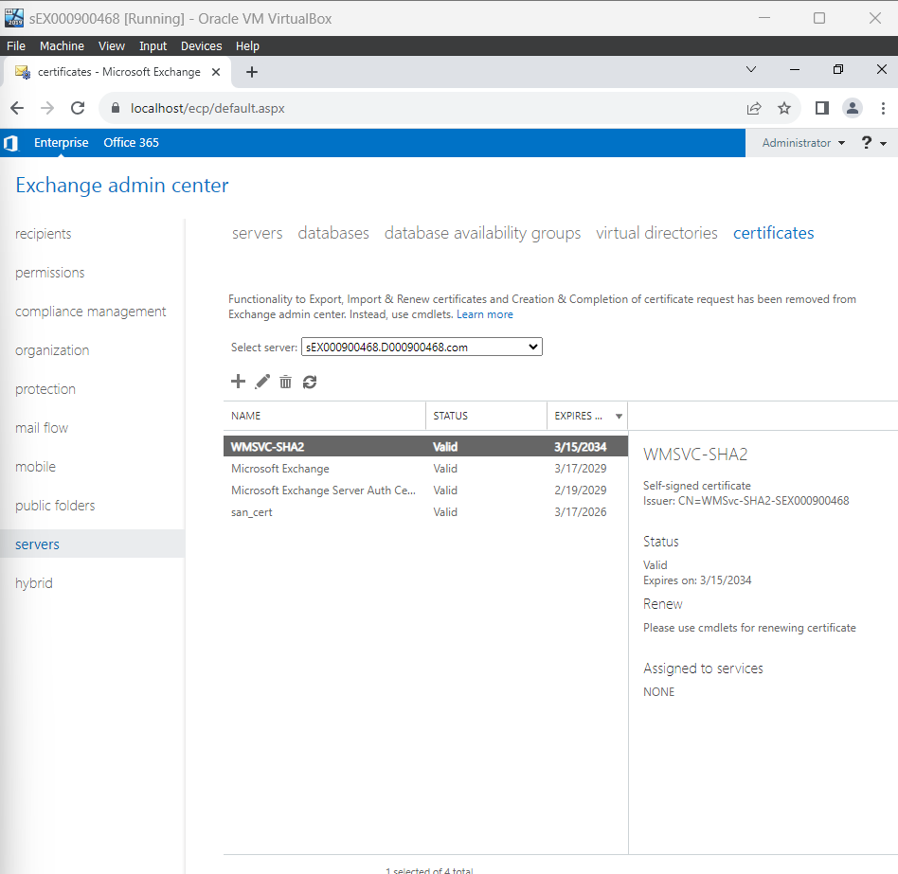

This certificate will allow us to use all mail services such as Imap and Pop3, this server will be configured to use Imap. We will also change the external and internal link names our users will use to connect to the OWA, we will make it something user friendly but also related to our domain like “mail.d000900468.com/owa”

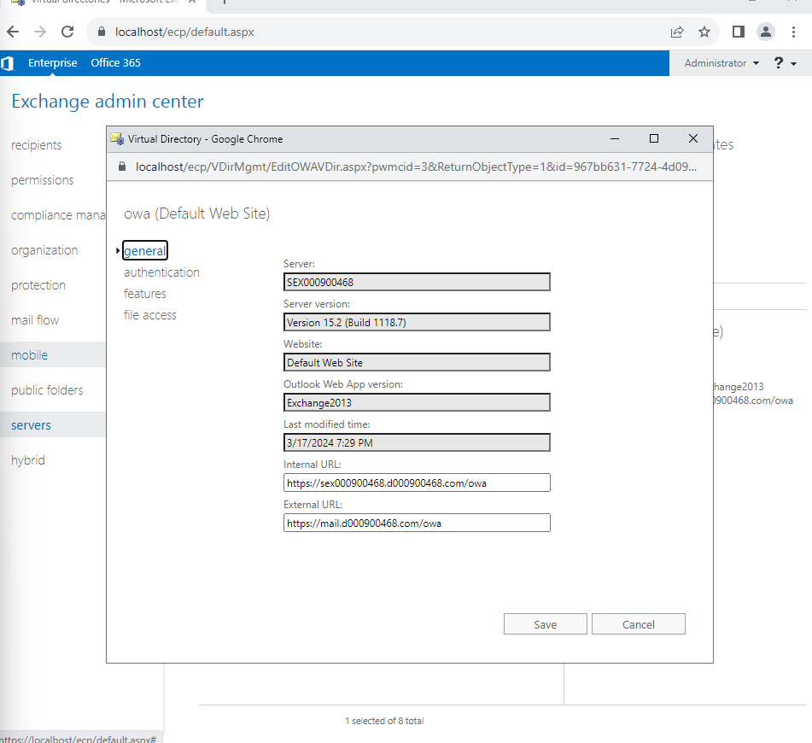

These were the steps taken to create a working exchange server for a domain, there are more post-installation steps to take if you'd like setting policies and thunderbird emailing but this is enough to deploy for a domain and its users.

# **Lessons Learned**

Things that I have learned while deploying the exchange server was how time consuming it is. To successfully get it working required patience and research, once completed it was rewarding. Another thing learned was how many things could be configured and or altered to your fitting.